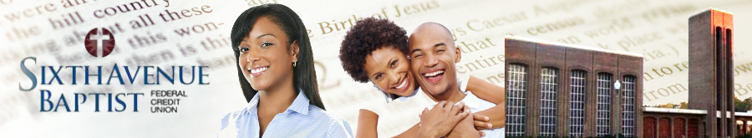
December 2021

FACTS | WHAT DOES SIXTH AVENUE BAPTIST FEDERAL CREDIT UNION(SABFCU) DO WITH YOUR PERSONAL INFORMATION?
Why? | Financial companies choose how they share your personal information. Federal law gives consumers the right to limit some but not all sharing. Federal law also requires us to tell you how we collect, share, and protect your personal information. Please read this notice carefully to understand what we do.
What? | The types of personal information we collect and share depend on the product or service you have with us. This information can include:  - Social Security Number and account balances  - Payment history and wire transfer instruction  - IP address, use of this website, online services  - Transaction history, account transactions, balances, payment history, & checking account information.  - Location  When you are no longer our member, we continue to share your information as described in this notice.
How? | All financial companies need to share members' personal information to run their everyday business. In the section below, we list the reasons financial companies can share their members' personal information; the reasons SABFCU chooses to share; and whether you can limit this sharing.
Reasons we can share your personal information |  | Do SABFCU and its affiliates share? | Can you limit this sharing?
For our everyday business purposes -  such as to process your transactions, maintain your account(s), respond to court orders and legal investigations, or report to credit bureaus |  | Yes | No
For our marketing purposes -  to offer our products and services to you |  | Yes | No
For joint marketing with other financial companies |  | Yes | No
For our affiliates' everyday business purposes -  information about your transactions and experiences |  | No | We don’t share
For our affiliates' everyday business purposes -  information about your creditworthiness |  | No | We don't share
For nonaffiliates to market to you |  | No | We don't share
Questions? | Call 205-322-6654 or go to https://www.sixthavebaptistfcu.org/  Sixth Avenue Baptist Federal Credit Union  1101 Martin Luther King, Jr. Dr. S.W.  Birmingham, AL 35211  sabfcu@sixthavebaptistfcu.org

Page 2

Who We Are
Who is providing this notice? | SABFCU and its affiliates means Sixth Avenue Baptist Federal Credit Union
What We Do
How does SABFCU protect my personal information? | To protect your personal information from unauthorized access and use, we use security measures that comply with federal law. These measures include computer safeguards and secured files and buildings.  We also maintain other physical, electronic, and procedural safeguards to protect this information and limit access to information to those employees for whom access is appropriate.
How does SABFCU collect my personal information? | We collect your personal information, for example, when you  - Open an account • Give us your contact information  - Apply for a loan • Show your driver's license  - Make deposits or withdrawals from your account  We also collect your personal information from others, such as credit bureaus, affiliates, or other companies.
Why can't I limit all sharing? | Federal law gives you the right to limit only  - sharing for affiliates' everyday business purposes - information about your creditworthiness  - affiliates from using your information to market to you  - sharing for nonaffiliates to market to you  State laws and individual companies may give you additional rights to limit sharing.
Definitions
Affiliates | Companies related by common ownership or control. They can be financial and non-financial companies.  - SABFCU has no affiliates.
Nonaffiliates | Companies not related by common ownership or control. They can be financial and non-financial companies.  - SABFCU does not share with nonaffiliates so they can market to you.
Joint Marketing | A formal agreement between nonaffiliated financial companies that together market financial products or services to you.  - Our joint marketing partners include insurance companies.
Other Important Information
COMPLAINT NOTICE: If you have a problem with the services provided by this credit union, please contact us at: SABFCU,C/O SUPERVISORY COMMITTEE, P.O. BOX 19395, Birmingham, AL 35219; phone 205-322-6654.

This credit union is incorporated under the laws of the Federal Credit Union Act and is subject to regulatory oversight by the National Credit Union Administration (NCUA). If any dispute is not resolved to your satisfaction, you may also file a complaint against the credit union by contacting NCUA through one of the means indicated below:

National Credit Union Administration, 1775 Duke Street, Alexandria, VA 22314 Phone: 703.518.6300 or 800.755.1030
Website: www.ncua.gov

